**Adagio – AR (View/Print Customer Statement)**

* ADAGIO ORDER ENTRY module
* ORDER ENTRY / DAY END PROCESSING  
    
  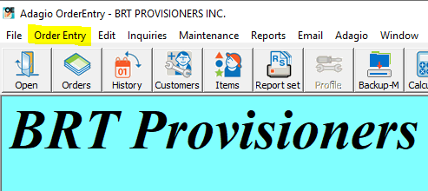
* CLICK “DAY END” button & then OK once complete
* ADAGIO RECEIVABLES module
* REPORTS / TRANSACTION & ANALYSIS REPORTS / TRIAL BALANCE
* You then select the date you want to see transactions safe for  
    
  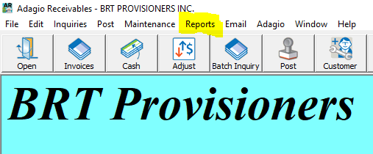

***This one gives you a summary, not really tidy to send to customers

IF YOU WOULD LIKE A NICE VERSION TO SEND TO CUSTOMERS

* ADAGIO RECEIVABLES module
* REPORTS / STATEMENT+LETTERS
* Print Menu will come up, and you can select the Customer Code you wish to print copy for.